PROJECT DOCUMENTATION / SOLUTION ARCHITECTURE

Solution Architecture
Layered architecture aligned to the incident lifecycle
DATE  07 October 2026 | STUDENT NAME  Gangadevi.R | PROJECT  Incident Life Cycle Automation

The architecture keeps the user interface, lifecycle/business rules, persistent data and scheduled automation responsibilities separate so each part can evolve without rewriting the whole system.
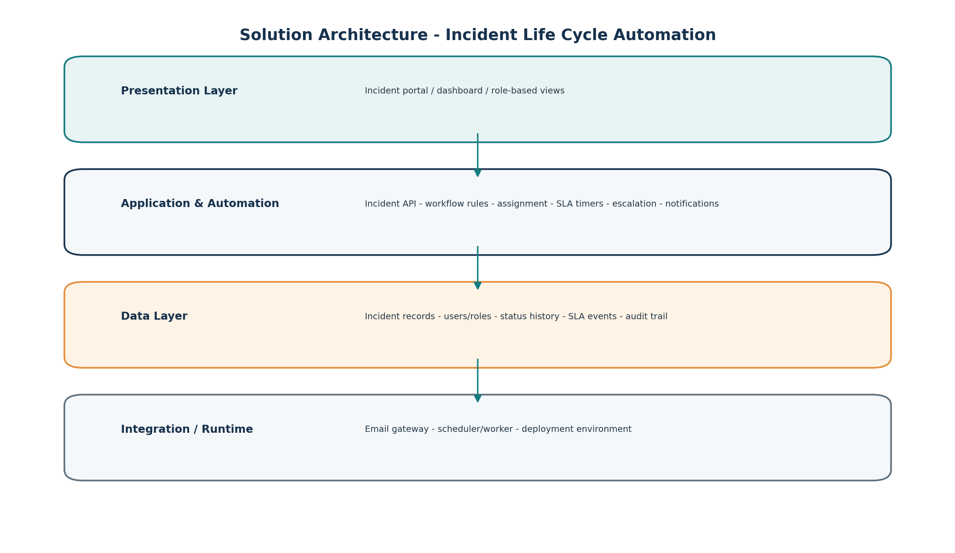

Key components
Layer | Key responsibility | Project components
Presentation | User interaction and visibility | Incident intake, incident detail, dashboard, filters, role-based actions
Application & Automation | Enforce lifecycle rules and automate decisions | Validation, triage, routing, status transitions, SLA timers, escalation, notifications
Data | Persist operational and audit information | Incidents, users/roles, workflow rules, status history, audit log
Integration / Runtime | Run scheduled work and deliver messages | Scheduler/worker, email gateway, runtime/deployment

